Experiment – 5

Measurement of Self Inductance by Maxwell Bridge

Aim :

Objective

* To determine the self-inductance of an unknown coil.

Theory :

Introduction

To determine the self-inductance of an unknown coil.

Theory

This bridge circuit measures an inductance by comparison with variable standard self inductance. The connections for balance condition is shown in Fig. 1.

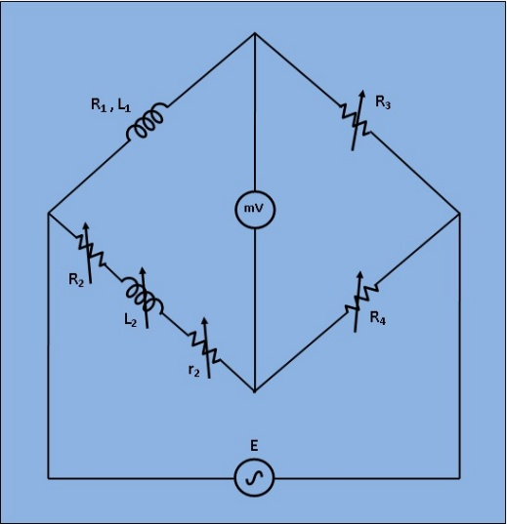 Fig 1: Circuit Diagram for Measurement of Self Inductance by Maxwell Bridge

Let, L1= Unknown self Inductance of resistance R1,

L2= variable inductance of fixed resistance r2,

R2= variable resistance connected in series with inductor L2,

R3,R4= known non inductive resistances,

At balance condition,



Equating both the real and imaginary parts in eq.(1) and seperating them,

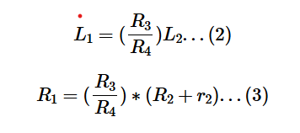

Resistors R3 and R4 are normally a selection of values from 10, 100, 1000 and 10,000Ω. r2 is a decade resistance box.

**Procedure :**

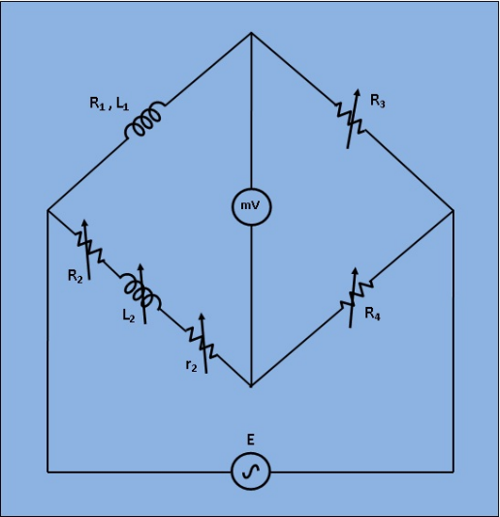

**Fig 1: Circuit Diagram for Measurement of Self Inductance by Maxwell Bridge**

1. Apply Supply voltage from the signal generator with arbitrary frequency. ( V =3v). Also set the unknown Inductance value from 'Set Inductor Value' tab.
2. Then switch on the supply to get millivoltmeter deflection.
3. Choose the values of L2, r2, R2, R3 and R4 from the inductance and resistance box. Varry the values to some particular values to achieve "NULL".
4. Observe the millivoltmeter pointer to achieve "NULL".
5. If "NULL" is achieved, switch to 'Measure Inductor Value' tab and click on 'Simulate'. Observe the calculated values of unknown inductance (L1) and it's internal resistance (R1) of the inductor.
6. Also observe the Dissipation factor of the unknwown inductor which is defined as,

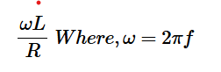

**Simulation :**

**CASE 1 - AIR CORE**

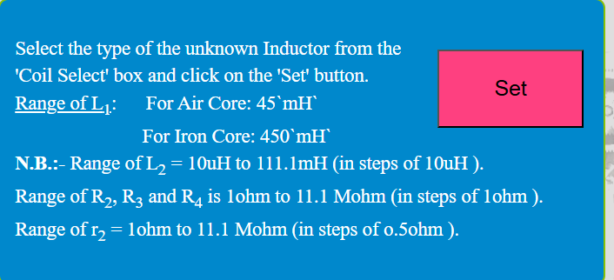

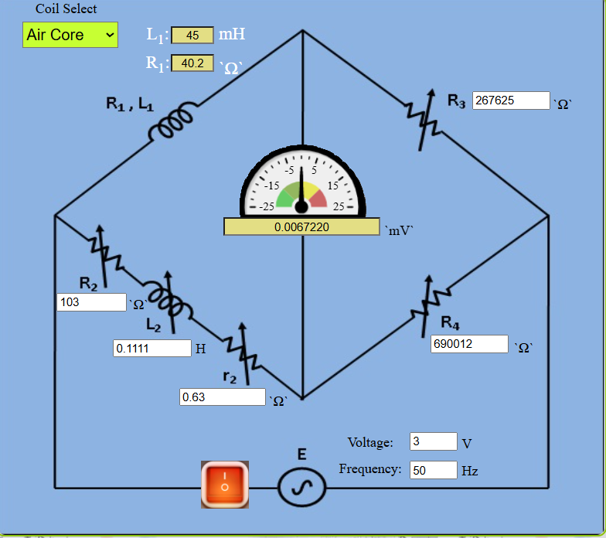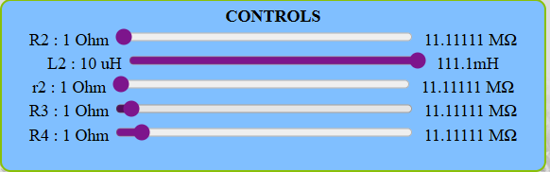

**Measure Inductor Value**

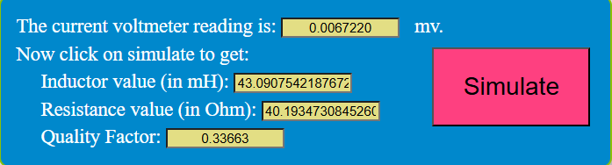

**CASE 2 – IRON CORE**

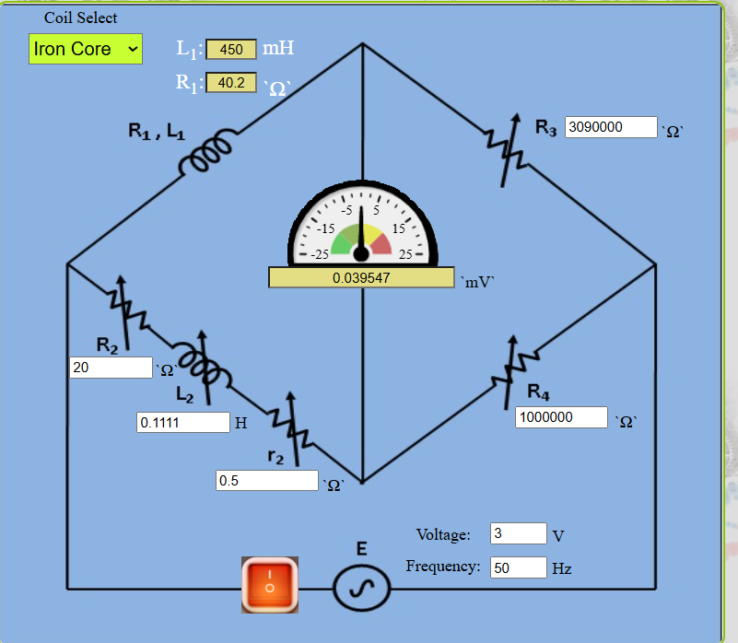

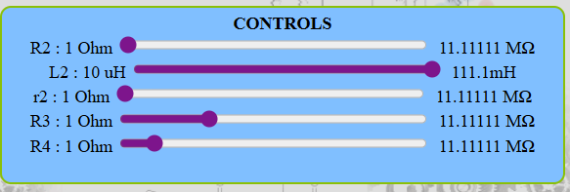

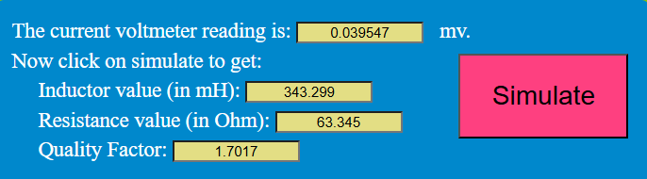

**Result :**

Thus the unknown inductance is found using Maxwell Bridge.